Adapted WRM curriculum overview for Elm Tree Primary School

At Elm Tree our Maths scheme of work is White Rose Maths. The White Rose Maths scheme outlines yearly frameworks which covers all aspects of the National Curriculum.
Our mission is to provide all our children with the same opportunity to learn with the support they need to fully grasp mathematical concepts. At the heart of the White Rose Maths scheme is the motto “Everyone can do Maths: Everyone can!” a vision that all at Elm Tree agree with. Through adopting both a CPA approach to learning and the Mastery Approach we are embedding a positive attitude towards Mathematics in all of our children and encouraging growth mindset.
White Rose Maths is a mainstream scheme of work and therefore the way we deliver the content is adapted in each class to take account of the complex learning needs of many of our children. Therefore children may be taught content based on their assessment step on B-Squared rather than their chronological year group to ensure all children’s knowledge is being built on strong foundations with a focus on promoting a deep and secure understanding before introducing the next mathematical concept. Therefore, in different areas of Maths children may access concepts from different year groups.
In addition, we recognise that for many of our children progression takes place through small steps and revisiting topics regularly helps to consolidate learning and maths fluency. Which is why we adopt a carousel approach to teaching Mathematics. Station 1 involves new teaching in line with the WRM SOW, Station 2 and 3 depends on the needs of the children but may include number formation, cardinality of number, space, shape and measure, vocabulary, times table practice and many more.
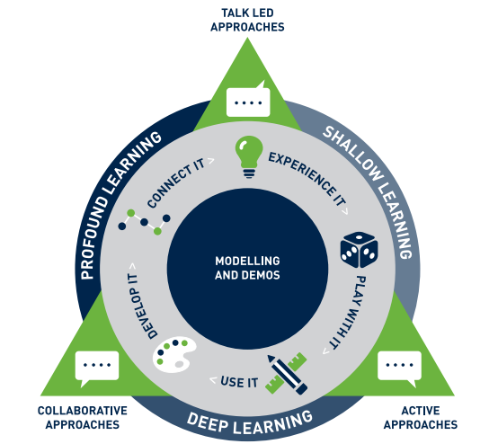
Gamification

The pedagogy of learning at our school is based on the Path 2 Success illustrated to the left. As we progress through the stages we develop from shallow learning to deep learning and ultimately to profound learning. As a result, we use engaging Maths games within the carousels to support the “play with it” aspect of progression and the intention of this is to improve recall and fluency of our children’s mathematical knowledge. The Maths games vary in each class to develop skills our children are currently learning, to consolidate previous learning, or to address gaps in mathematical knowledge.
Reception aged children or children at Progression Step 1, 2 or 3 on B-Squared
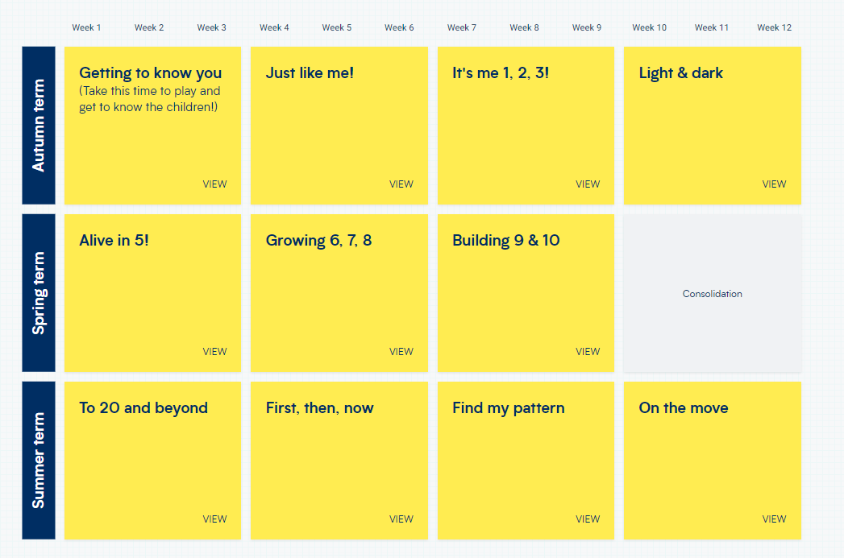

Year 1 aged children or children at Progression Step 3 or 4 on B-Squared
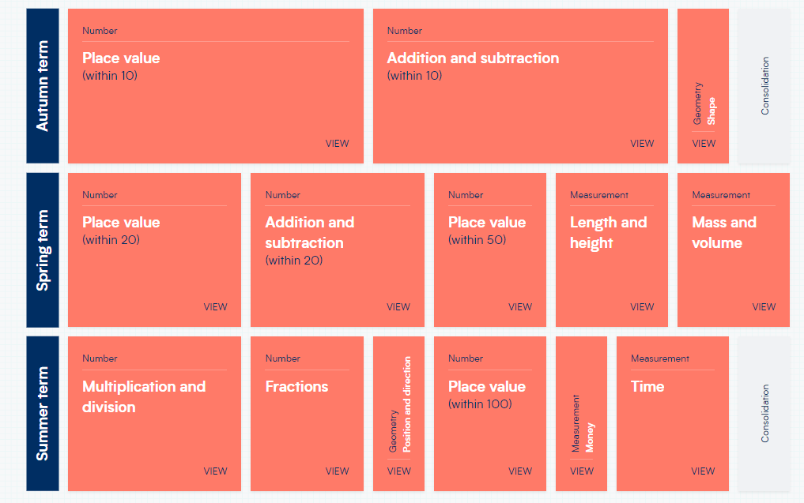

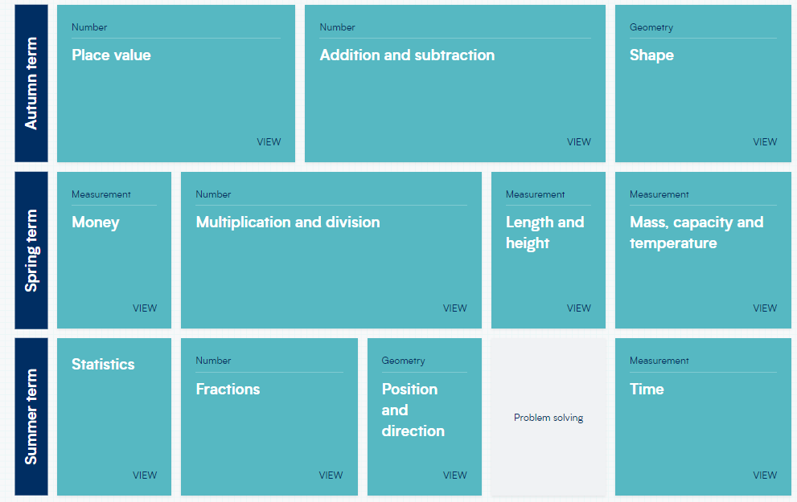
Year 2 aged children or children at Progression Step 5 and 6 on B-Squared

Year 3 aged children or children at Progression Step 6 and 7 on B-Squared
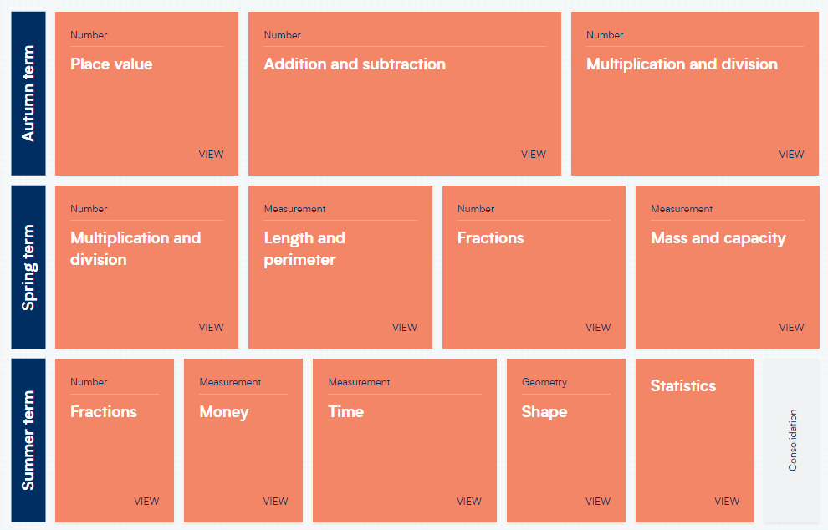

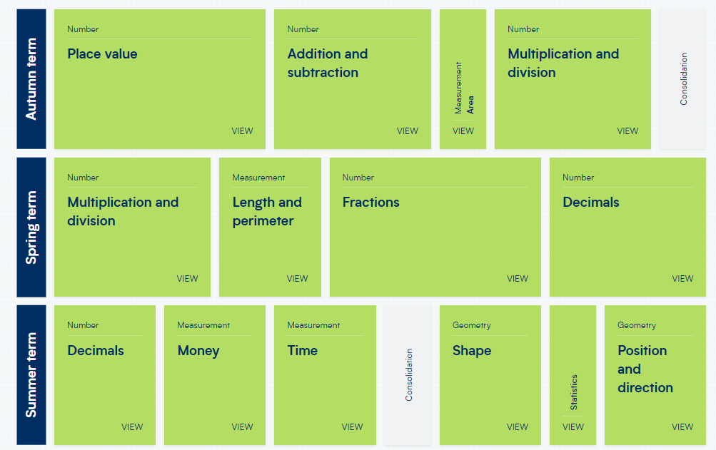
Year 4 aged children or children at Progression Step 7 on B-Squared

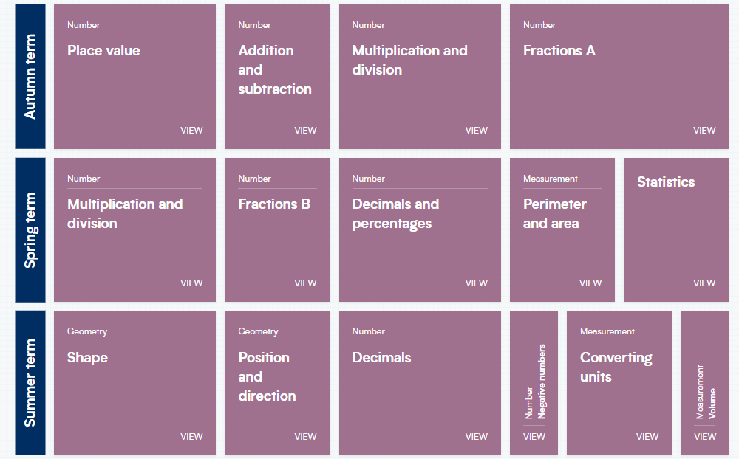
Year 5 aged children or children at Progression Step 8 on B-Squared

Year 6 aged children or children at Progression Step 8 or 9 on B-squared.
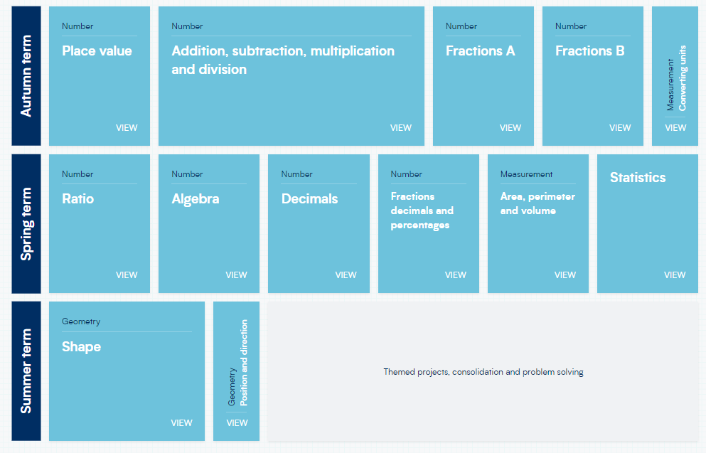

Blank Levels
As a school we recognise that some of our children have significant speech and language delays and may be on blank levels which are much lower than their subject specific knowledge. Therefore, teachers may adjust problem solving or word problems to be appropriate for the blank level of the child.

