‘Use it’ and ‘Develop it’: Calculation and Thinking

Addition

Objective and strategies | Concrete | Pictorial | Abstract
Combining two  parts to make  a whole (Part-part whole model) | 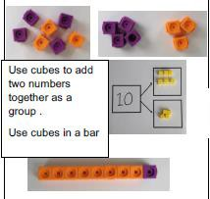 | 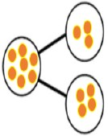  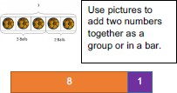 | 4 + 3 = 7 (four is a part, 3 is a part and the whole is seven)  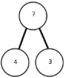
Starting at the  bigger number and counting on | 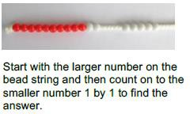 | 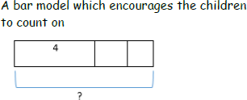 | 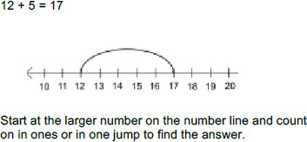

 | 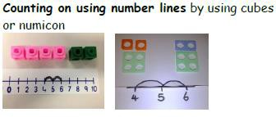
Regrouping to  make 10. | 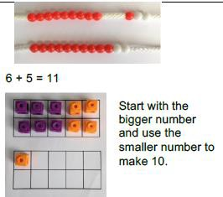 | 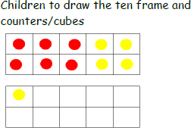  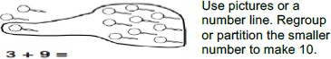 | 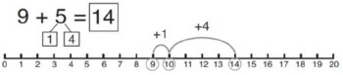  7 + 4= 11  If I am at seven, how many more do I need to make 10. How many more do I add on now?

Adding three single digits.  Children look for near doubles or number bonds and add together first. | 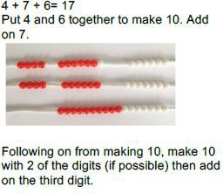 | 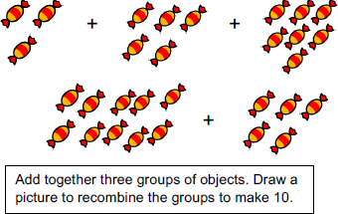 | 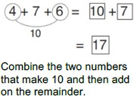
Column method- no regrouping | 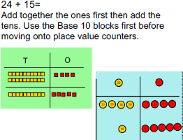  20 + 4 40 + 4  10 + 5 10 + 5  30 + 9 =39 50 + 9 = 59 | After practically using the base 10 blocks and place value counters, children can draw the counters to help them to solve additions.  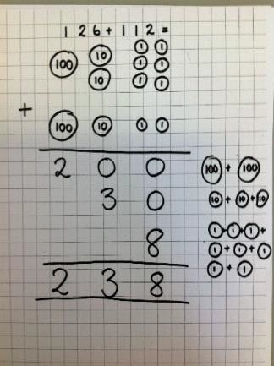 | 20 + 1  40 + 2  60 + 3 = 63  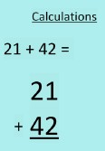

Column Method regrouping | 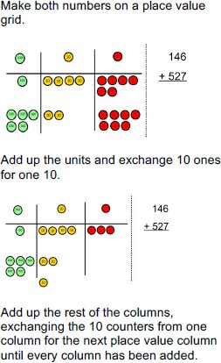  This can also be done with Base 10 to help children clearly see that 10 ones equal 1 ten and 10 tens equal 100.  As children move on to decimals, money and decimal place value counters can be used to support learning. | 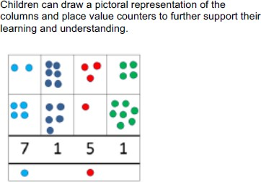 | 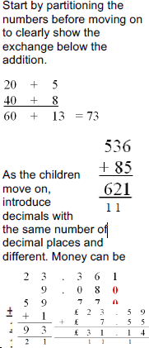

Fluency variation, different ways to ask children to solve 21+34:
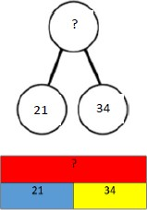 | Sam saved £21 one week and £34 another. How much did he save in total?  21+34=55. Prove it! (reasoning but the children need to be fluent in representing this) | 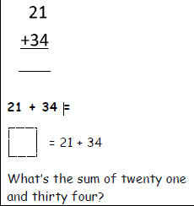 | 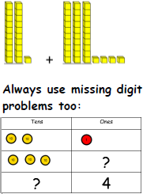

Subtraction

Objective and  strategies | Concrete | Pictorial | Abstract
Physically taking away and removing objects from a whole (use various objects too) rather than crossing out- children will physically remove the objects | 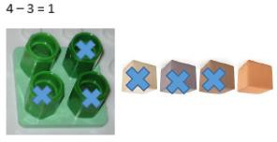  Use physical objects, counters, cubes etc to show how objects can be taken away.  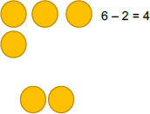 | 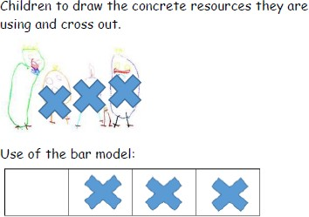  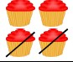 | 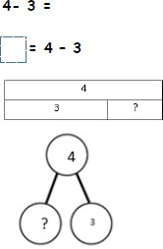

Counting back | 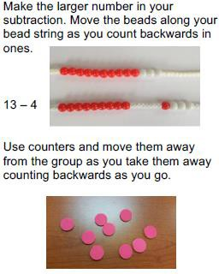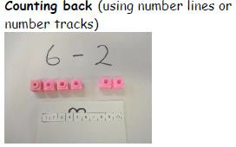 | 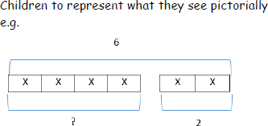  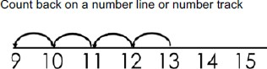 | 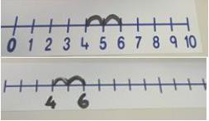  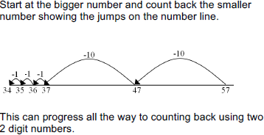  Put 13 in your head, count back 4. What number are you at? Use your fingers to help.

Find the difference | 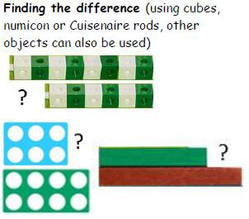 | 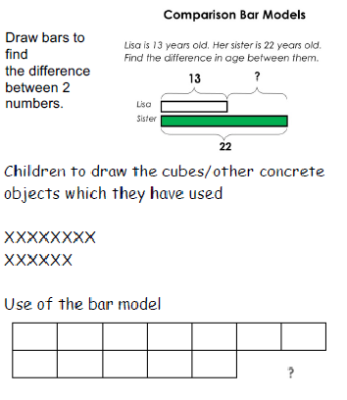 | 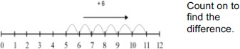  Find the difference between 8 and 6. 8 – 6, the difference is ?  Children to also explore why 9 - 7 = 8 – 6 (the difference, of each digit, has changed by 1 do the difference is the same- this will help when solving 10000-9987)
Part -Part Whole Model  – linked back to addition. | 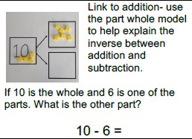 | 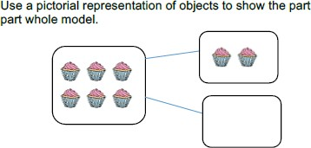 | 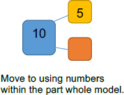

Make 10 | 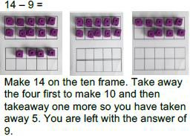 | 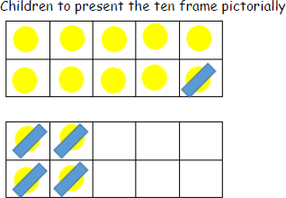 | 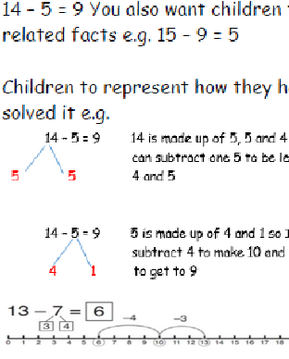
Column method without regrouping | 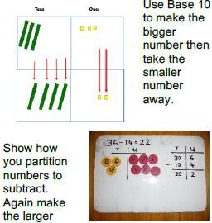 | 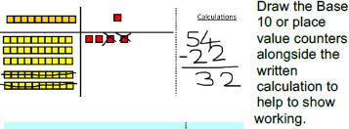  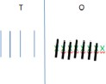 | 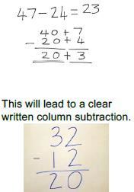

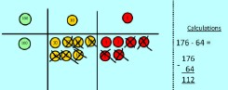

Column method with regrouping and replacing. | 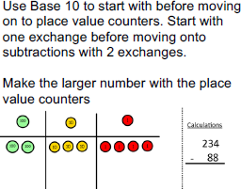  Start with the ones, can I take away 8 from 4 easily? I need to exchange and replace one of my tens for ten ones.  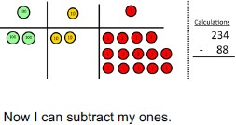  Now look at the tens, can I take away 8 tens easily? I need to exchange and replace one hundred for ten tens. | 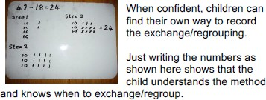  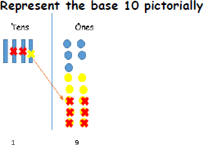 | 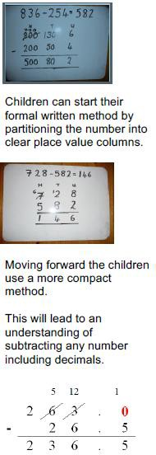

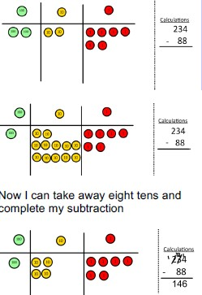
Show children how the concrete method links to the written method alongside your working. Cross out the
numbers when exchanging and replacing and show where we write our new amount.

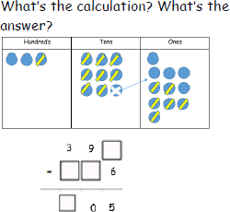

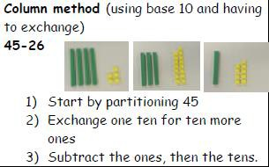

Fluency variation, different ways to ask children to solve 391-186:
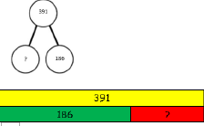 | Raj spent £391, Timmy spent £186. How much more did Raj spend?  I had 391 metres to run. After 186 I stopped. How many metres do I have left to run? | 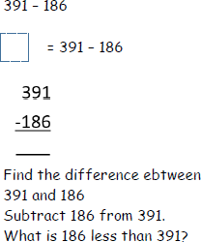 | 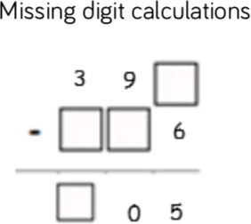

Multiplication

Objective and  strategies | Concrete | Pictorial | Abstract
Doubling | 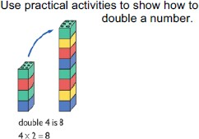 | 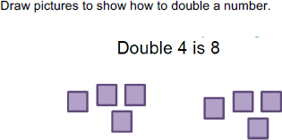 | 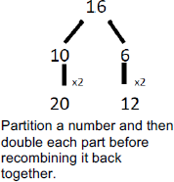
Counting in multiples | 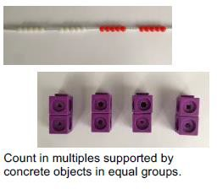 | 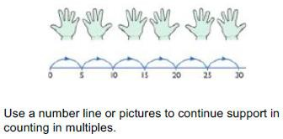 | Count in multiples of a number aloud.  Write sequences with multiples of numbers. 2, 4, 6, 8, 10  5, 10, 15, 20, 25 , 30  Games used to practice.

12
4 | 4 | 4

Repeated addition | 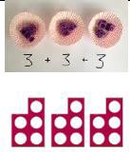  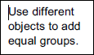  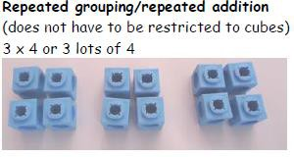  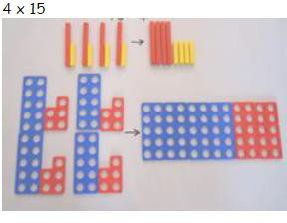 | 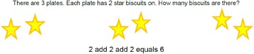  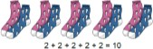  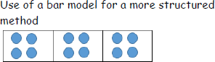 | Write addition sentences to describe objects and pictures.  3 x 4  4+ 4 + 4

Use arrays to illustrate commutati vity | 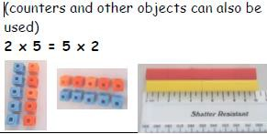  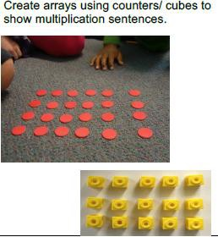 | 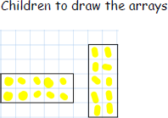  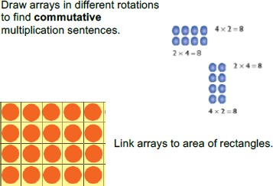 | Children to be able to use an array to write a range of calculations e.g.  2 x 5 = 10  5 x 2 = 10  2 + 2 + 2 + 2 + 2 = 10  5 + 5 =10  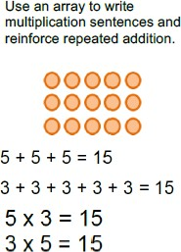

Use number lines to show repeated groups. | 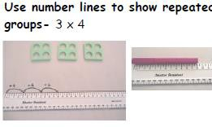 | 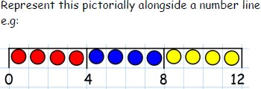 | 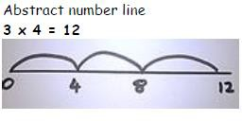
Using known facts for multiplying by multiples of 10, 100 and  1000  Pupils’ growing understanding of place value, allows them to make use of known facts to derive multiplications using powers of 10.  It is important to use tables with which they are already familiar (i.e. not 7 or 9 tables in Year 3) | 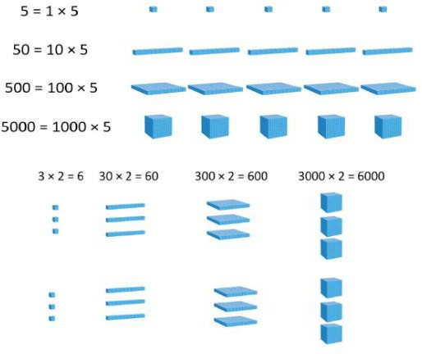 | 32 x 100  Take 32 ‘ones’ and replace them with 32 ‘one hundreds’. What happens when we times by 100?  We are trying to avoid answers like add two zeros with limited understanding. They should see and be able to explain that each part we have multiplied by 100 is 100 times larger. | 360 ÷ 10 = 36

Grid Method | 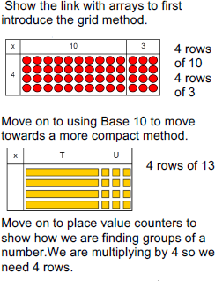 | 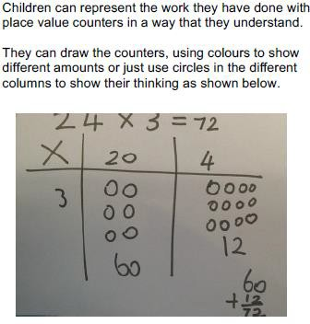 | 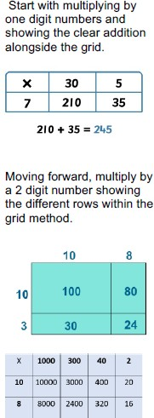

Short Column Multiplicati on | 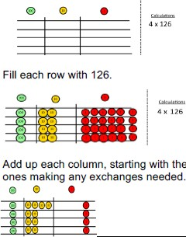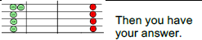 | 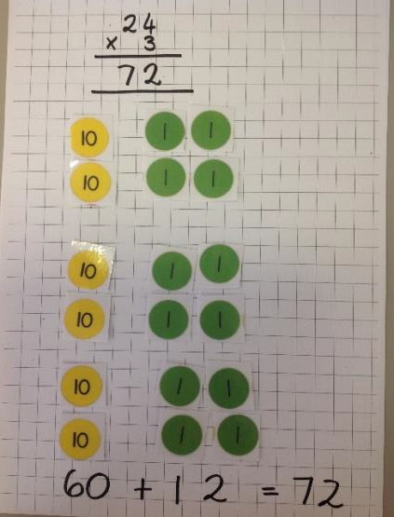 | 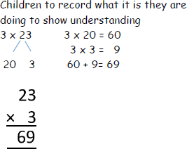
Fluency variation, different ways to ask children to solve 6 x 23:

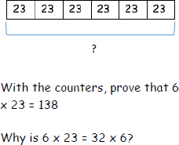 | Mai had to swim 23 lengths, 6 times a week. How many lengths did she swim in one week?  Tom saved 23p three days a week. How much did he save in 2 weeks? | 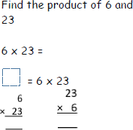 | 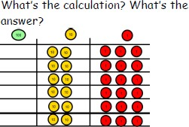

Division

Objective and  strategies | Concrete | Pictorial | Abstract
Sharing objects into groups | 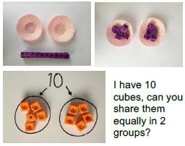  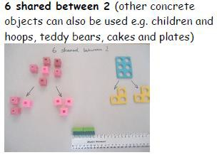 | 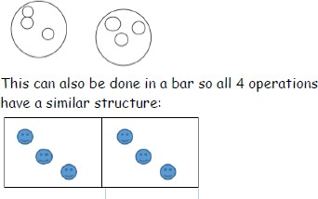 | 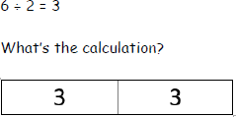

28
7 | 7 | 7 | 7

Division as grouping and repeated subtraction. | 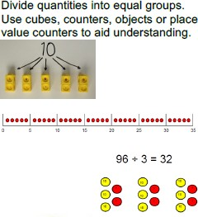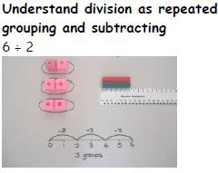 | 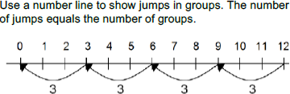  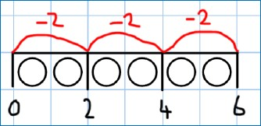 | 28 ÷ 7 = 4  Divide 28 into groups of 7. How many are in each group?

Division with arrays including fact families and inverse | 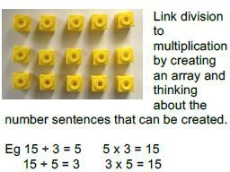 | 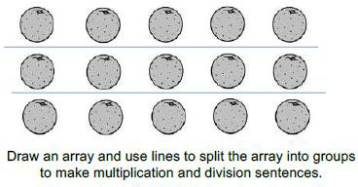 | Find the inverse of multiplication and division sentences by creating four linking number sentences. 7 x 4 = 28  4 x 7 = 28  28 ÷ 7 = 4  28 ÷ 4 = 7
Division with a remainder | 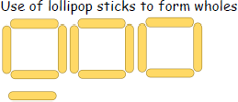 | 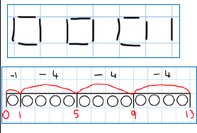 | 13 ÷ 4 = 3r1  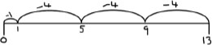

 | 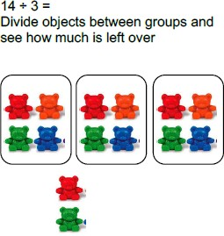
Using known facts for dividing by multiples of 10, 100 and  1000 | 500 ÷ 10  Show using base 10 - showing 50 tens.  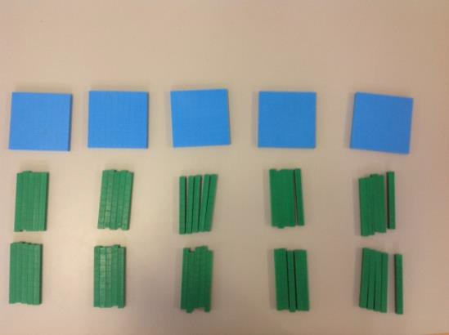 | 400 ÷ 10 =  Show sharing PV counters into groups  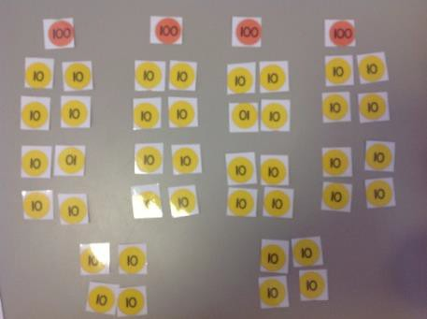  27 ÷ 10 =  Show with PV counters sharing into groups.

Short division | 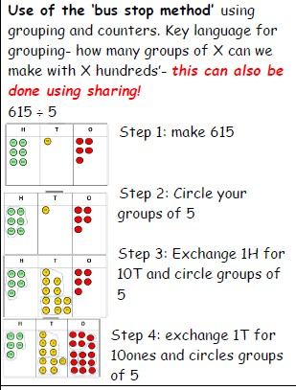 | 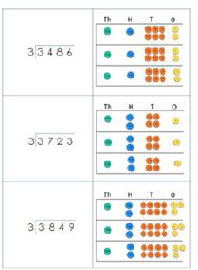 | 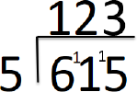

Long division | 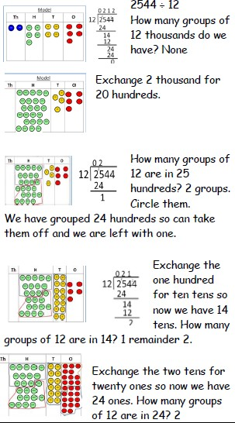 | Children to represent the counters, pictorially and record the subtractions beneath. | 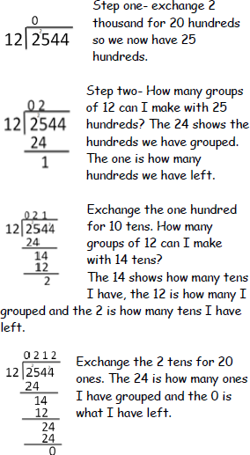

Fluency variation, different ways to ask children to solve 615 ÷ 5:
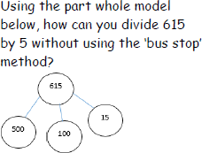 | I have £615 and share it equally between 5 bank accounts. How much will be in each account?  615 pupils need to be put into 5 groups. How many will be in each group? | 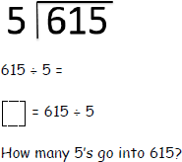 | 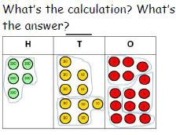

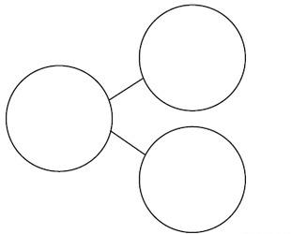
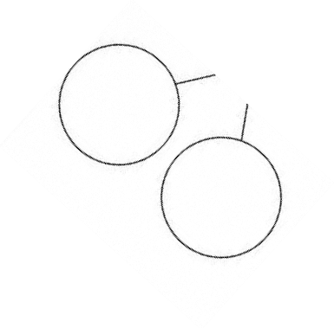
Fractions

Objective and  strategies | Concrete | Pictorial | Abstract
Identifying half as 2 equal parts or quarter as 4 equal parts of a quantity | Using physical resources, children manipulate skittles, sweets, cubes to link back to parts having to be equal.  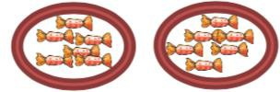  One half of 12 is 6.  “There are two equal parts, 6 is one equal part of the whole.”  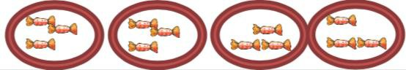  One quarter of 12 is 3.  “There are four equal parts, 3 is one equal part of the whole.” | Representations are chosen to support pupils’ understanding of fractions, e.g part-part-whole models | Pupils are confident to use a range of abstract written versions:  12 ÷ 4 = 3  or  Half of 16 is 8  Or they use the pictorial representation with abstract numerals  4  8  4

write simple fractions for example, 1/2 of 6 = 3 | Pupils will make links between division and fractions using denominators  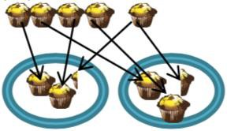 | A range of pictorial representations can be used to demonstrate fractions, always linking back to equal parts in a whole.  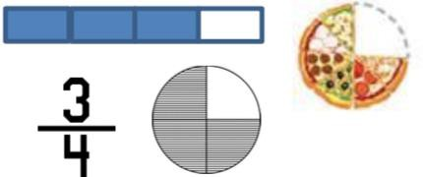 | 1 of 12 is 4  3  To find three quarters of a number, you can find the four equal parts and calculate the total of three of those four parts
recognise that tenths arise from dividing an object into 10 equal parts and in dividing one- digit numbers or quantities by 10 | Use place value knowledge and a tens frame to identify that 1 split into 10 equal parts è each equal part is 1 tenth  0. 0. 0. 0. 0.  0. 0. 0. 0. 0.  Equally, 10 equal parts that are tenths combined is the same as 1 whole | 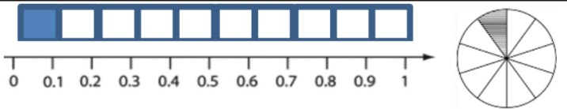  These pictorial representations demonstrate what happens on a number line, with blocks or cubes or with circles when sharing into 10 equal parts.  N.B Consider how these represent the decimals between 0 and 1, i.e 6 of the 10ths is the same as 0.6. 10 of the 10ths is the same as 1. | Divide an object into 10 equal parts and you have ten tenths.  If you divide whole numbers into 10th, each whole is divided into 10 equal parts. Each part is 1 tenth. If you divide 3 into tenths, each whole provides 1/10 which combined total 3/10.

Add and subtract fractions with the same denominator (within and to beyond 1) | Using different shaped fraction tools allows pupils to manipulate and compare fractions  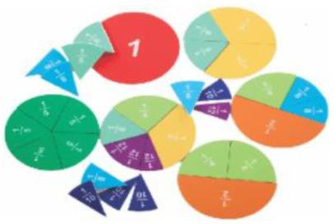 | Use a range of representations to demonstrate two fractions being like fractions, i.e each part is always the same. |  |  |  |  |  |  |  |  | 5/8 and 1/8 are like fractions as they have the same denominator.  How much of a pizza / chocolate bar would this be all together?  5/8 + 1/8 = 6/8
 |  |  | 4/7 + 2/7 = 6/7  I have split the whole into seven equal parts. I take 4 of those 7 equal parts and combine it with 2 more of those equal parts – how many o the 7 equal parts do I have in total?  You can also represent this: |  |  |  |  |  |  | f
 |  | 4/7 + 6/7 = 10/7 or 1 and 3/7

Subtraction works with the same model:
9/10 – 4/10 is:

I have split the whole into ten equal parts. I take 9 of those 10 equal parts and subtract 4 of those equal parts – how many of the 10 equal parts do I have left?

5 of the 10 equal parts remain (or I have 5/10 left over).

recognise that hundredths arise when dividing an object by one hundred and dividing tenths by ten. | Use place value knowledge and a tens frame to identify that 0.1 split into 10 equal parts è each equal part is 1 hundredth  0.01 0.01 0.01 0.01 0.01  0.01 0.01 0.01 0.01 0.01  Equally, 10 equal parts that are hundredths combined is the same as 1 whole | 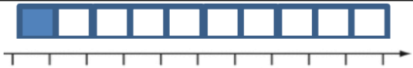  0 0.01 0.02 0.03 0.04 0.05 0.06 0.07 0.08 0.09 0.10 (or we can write 0.1)  Similar to looking at tenths, pictorial representations linked to number lines can help us to get a sense of the size of hundredths.  Similarly, you can use empty hundred squares on lined paper to support them with the idea of size and proportion of these fractions.  This is one tenth of the whole (10 out of 100) | Divide an object into 100 equal parts and you have one hundred hundredths.  If you divide whole numbers into 100ths, each whole is divided into 100 equal parts. Each part is 1 hundredth. If you divide 7 into hundredth, each whole provides 1/100 which combined total 7/100.

This is one hundredth of the whole (1 out of 100)

You can also use fraction bars to show the difference in size.

This represents one tenth.

This represents one hundredth.

Add and subtract fractions with denominators that are multiples of the same number. | When demonstrating this to pupils, using paper strips is useful.  3/8 + ¼ = ?  You can show that the lowest common multiple is linked to their knowledge of equivalent fractions.  ¼ is the same as 2/8: |  |  |  |  |  |  |  |  |  | Asking the pupils to draw a representation either on a bar or a circle can be useful:  2/5 + 1/2  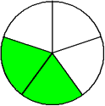 + 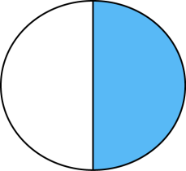  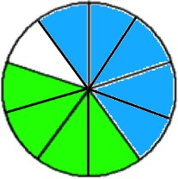 | 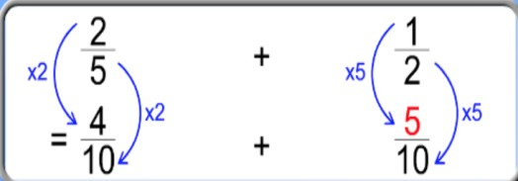  When adding two fractions with different denominators, we need to look for the lowest common multiple and convert both numbers (if necessary) to this fraction.  For example, 5 and 2 have the lowest common multiple of 10 – so to add these together, we need to ensure we keep to rules of equivalence (same rule applied to numerator and denominator).
 |  | =
 |  | So now we can add the two fractions:
 |  | +
 |  | =
 | The total is 5/8

Multiply proper fractions and mixed numbers by whole numbers | ½ x 5  Using strips of paper is an excellent practical resource to support understanding of this concept.  This is ½ of the whole.  5 x n (n meaning any number) is the same as 5 groups of n.  Therefore 5 x ½ is the same as 5 groups, with half in each group.  +  +  +  + |  |  |  | 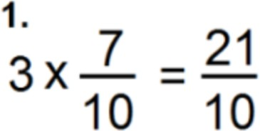  If this is 7/10 (7 tenths):  Then this would be 3 groups of 7/10 (7 tenths):  The product is clear 21 tenths (because each whole is split in to 10 equal parts and the denominator represents this information). | The reason why this works:  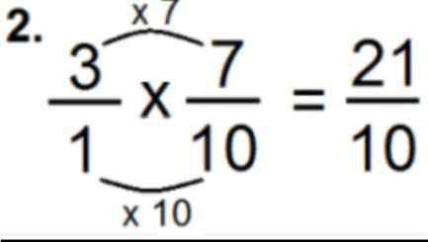  …is because you do have ‘3 wholes’ (or 3/1) – if they are getting too focused on this  method alone and start to forget why it works, move them back into concrete or abstract methods.

Combined, it would look like this:

The product must be 2 and a half or 2 ½

Multiplying a mixed number is the same:

2 ½ x 2

To add and subtract fractions with different denominators and mixed numbers (using equivalent fractions) | Practical resources such as cuisineaire allow you to see mixed fractions:  If Dark Green is 1 whole then… | If we take the example of adding 2 and 2/3 with 3 and  ¾ then we can consider that the wholes and parts can be combined separately before being combined as two new totals. |  |  |  |  |  |  |  | 2 and 2/3 plus 3 ¾  2 wholes plus 3 wholes is 5 wholes This leaves us with 2/3 plus ¾  Now we are simply adding two fractions with different denominators.  The rules of equivalence inform us that the lowest common multiple is 12 and so we convert both fractions.
 |  |  | +
 | What is light green?  What is the total of this number? |  |  |  |  |  |  |  |  | 2 x 4 = 8 and 3 x 3 = 9  3 x 4 12 4 x 3 = 12
 | What if I had 2 more wholes? What would I have in total now? |  |  |  |  |  |  |  |  | Now we can add them together which will total 17/12 or 1 whole and 5/12.
 |  |  |  |  |  |  |  |  |  | If we combine this with 5 wholes, we would have 6 wholes and 5/12.
 |  |  | So we have:

5 wholes plus a further…

1 whole and 5/12
 |  | Combining both of these physically, pictorially or abstract will allow us to see that there are 6 wholes and 5/12
To multiply simple pairs of proper fractions (writing the answer in its simplest form) | Start with what they do know:  Each pink block is worth ¼ so ¼ x 3 = 3 groups of ¼ We can write this as:  ¼ + ¼ + ¼ = ¾ | If this is one whole.  1 x 1 = 1 |  |  |  |  |  |  |  |  |  |  |  |  |  | 1x 1 = 1  4 2 8  2 x 1 = 2 = 1  3 4 12 6  They should be expected to draw it to continue demonstrating, and developing, their conceptual understanding.  This will support ‘genuine’ fluency  and therefore application.

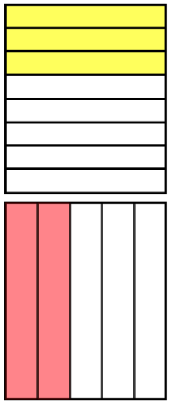
Each pink block is worth ¼ so ¼ x 1 = 1 group of ¼ is ¼ We can write this as:
¼ = ¼

Each pink block is worth ¼

So ¼ x 1/3 = 1/3 of 1 group of ¼ We can write this as:
1 group of ¼ is ¼

1/3 of 1 group of ¼ is 1/12.

First, you split into three equal sections as we need to find 1/3 of one group of
¼.

Then this is the whole shared equally into 8 equal parts.

This is 3 of the 8 equal parts. 1 group of 3/8 = 3/8

Then this is the whole shared equally into 5 equal parts.

This is 2 of the 5 equal parts. 1 group of 2/5 = 2/5
3 × 2 8 5
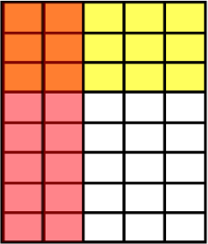

Relate to what pupils know
already.

When we had 1 group of 2/5, the product was 2/5. Now we are calculating what 3/8 of
1 group of 2/5 would be.

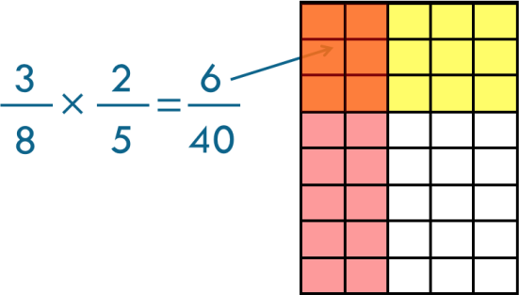

6 and 40 have common factors of 1 and 2. Dividing it by the Highest Common Factor (HCF) will provide th is fraction in its simplest form: 3/20
To divide proper fractions by whole numbers | Always start with a familiar context.  ½ of a pizza is to be shared between four friends. How much do they each get?  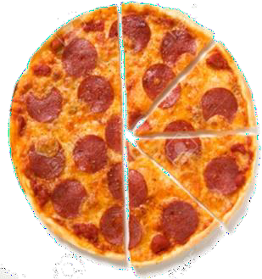 | 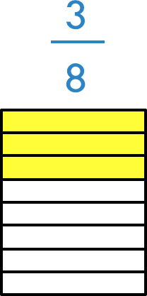  What is the generalisation? | 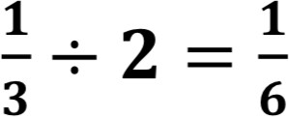  Pupils understand the strategy and can calculate mentally.  If necessary, they can use simple drawn models if they confuse their own understanding.

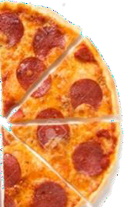

 | 3/8 of the pizza remains. Two friends are going to share it equally.  Each friend will get half each. How can we represent this? | Multiply the denominator by the whole number. The numerator stays the same. Why does this work?  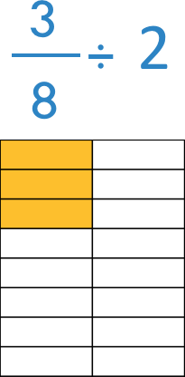  This is 3/16 because you have shared 3/8 equally between two people meaning they get half each. Half of 3/8 is 3/16. | 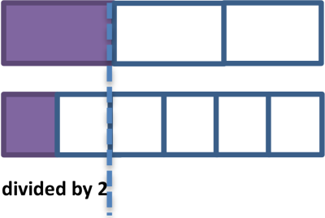

 | 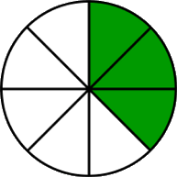  Find half of the 3/8.  Now to ensure you are representing it fairly, you have to make sure all the parts are equal (e.g sixteenths, so draw the rest of the grid out to support in counting that each child has three sixteenths – see below).  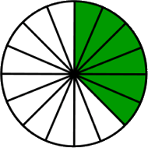 | 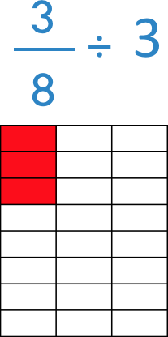  This pattern continues. 3/8 shared equally between three people will mean they get one third each. One Third of 3/8 is 3/24.  