SEND Policy and Information Report

Elm Tree Community Primary School

Approved by: | D. Lamb & Governing Body | Date: September 2022
Last reviewed on: | September 2021
Next review due by: | September 2023

1. Aims

Philosophy and Purpose

This policy reflects the school values and philosophy in relation to Special Educational Needs. It sets out a framework within which teaching and non-teaching staff can operate and gives guidance on practice within school.

Provision

Elm Tree is a community special school which opened in September 2008. The school caters for primary aged pupils holding Education, Health and Care Plans for Social, Emotional, Mental Health and a range of other complex needs. The school was formed from the re-organisation of Beacon all age special school, into age phased provision, in line with the Lancashire County Council Inclusive Continuum Action Plan. The school is accommodated in a refurbished primary school building in a pleasant residential area of Skelmersdale, close to a nearby council estate and the previous school building. It is a pleasant and airy building with large playgrounds, a Multi-Use Games Area and playing fields with good sized classrooms, well equipped with ICT and appropriate furnishings. The school has refurbished the outside with playground and gym equipment, a Multi-Use Games Area, outside classroom and sports equipment. We have invested in 5 mobile ICT suites which are used throughout the school; a new wireless internet connection has simplified this process. The school has a sensory suite, Occupational Therapy room, soft play area and a range of other intervention pods to host academic intervention work for literacy and numeracy, multi agency collaboration work, i.e. Counselling, Speech & Language, Play and Music Therapy. Elm Tree is a popular school with a very large geographic catchment area, including pupils from Fleetwood, Morecambe, Preston, Rossendale, Leyland, Chorley and West Lancashire. We also have on roll pupils from out of county areas such as Wigan, Sefton, St Helens and Liverpool.

It is the policy of this school to fulfil all that is required under the statutory instrument: The Education (Special Educational Needs) (Information) Regulation 1994 and to be guided by the advice and guidelines published by the Lancashire Education Authority and any subsequent changes to the statute or advice.

Blueprint

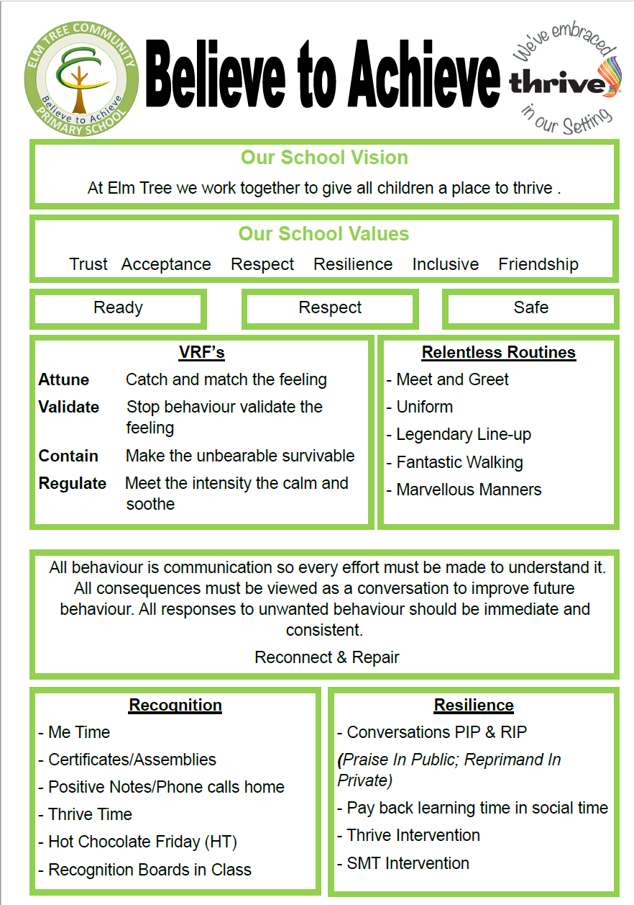

Aims of the School

The Governors and staff of Elm Tree Community Primary School aim to provide equal opportunities for all through:

1. An inclusive ethos of respect, tolerance, and understanding of others’ needs developing and valuing pupils’ self-discipline, independence and autonomy.

2. A safe supportive, caring and dynamic school environment, extending into the wider Community where all are valued as educators and partners in school improvement.

3. Access to the National Curriculum and the extended school designed to accommodate individual pupil needs and to ensure maximum progress.

4. An environment where creativity is nurtured and provide a medium for driving forward school improvement.

5. The celebration of success and positive outcomes for all.

We aim to:

• Develop a nurturing culture of lifelong learning for staff and pupils;
• Promote intellect, physical, social, aesthetic, spiritual and moral development of pupils;
• Inspire communication and independence skills;
• Prepare pupils to control their own lives;
• Help and encourage pupils to become valued employers, employees and members of social groups and communities;
• Promote a healthy lifestyle and a sense of self-worth;
• Develop lively, inquiring, creative minds;
• Ensure that creative and inspirational teaching leads to exciting, enjoyable and inspired learning;
• Maintain the highest personal expectation of each pupil, recognising and developing strengths and talents;
• Engage learners in meaningful work related learning, developing ambition and enterprise skills and securing best possible post school outcomes;
• Have a wider local, regional and national influence to ensure pupils access best practice and schools within our locality are well supported.

2. Legislation and guidance

This policy and information report is based on the statutory Special Educational Needs and Disability (SEND) Code of Practice and the following legislation:
- Part 3 of the Children and Families Act 2014, which sets out schools’ responsibilities for pupils with SEND and disabilities
- The Special Educational Needs and Disability Regulations 2014, which set out schools’ responsibilities for education, health and care (EHC) plans, SEND co-ordinators (SENDCOs) and the SEND information report

This policy also complies with our funding agreement and articles of association.

3. Definitions
A pupil has SEND if they have a learning difficulty or disability which calls for special educational provision to be made for them.
They have a learning difficulty or disability if they have:
- A significantly greater difficulty in learning than the majority of others of the same age, or
- A disability which prevents or hinders them from making use of facilities of a kind generally provided for others of the same age in mainstream schools
Special educational provision is educational or training provision that is additional to, or different from, that made generally for other children or young people of the same age by mainstream schools.

4. Roles and responsibilities
4.1 The SENDCO / Headteacher
The SENDCO is Mr S Brown and the Headteacher is Mr D Lamb
They will:
- Work with professionals to determine the strategic development of the SEND policy and provision in the school
- Have day-to-day responsibility for the operation of this SEND policy and the co-ordination of specific provision made to support individual pupils with SEND, including those who have EHC plans
- Provide professional guidance to colleagues and work with staff, parents, and other agencies to ensure that pupils with SEND receive appropriate support and high quality teaching
- Advise on the graduated approach to providing SEND support
- Advise on the deployment of the school’s delegated budget and other resources to meet pupils’ needs effectively
- Be the point of contact for external agencies, especially the local authority and its support services
- Liaise with potential next providers of education to ensure pupils and their parents are informed about options and a smooth transition is planned
- Work with the governing board to ensure that the school meets its responsibilities under the Equality Act 2010 with regard to reasonable adjustments and access arrangements
- Ensure the school keeps the records of all pupils with SEND up to date

4.2 The SEND governor
The SEND governor will:
- Help to raise awareness of SEND issues at governing board meetings
- Monitor the quality and effectiveness of SEND and disability provision within the school and update the governing board on this
- Work with the headteacher / SENDCO to determine the strategic development of the SEND policy and provision in the school

4.3 Class teachers
Each class teacher is responsible for:
- The progress and development of every pupil in their class
- Working closely with any teaching assistants or specialist staff to plan and assess the impact of support and interventions and how they can be linked to classroom teaching
- Working with the SENDCO to review each pupil’s progress and development and decide on any changes to provision
- Ensuring they follow this SEND policy

5. SEND information report
Admissions

Following assessment procedures which result in the issuing of an Education, Health & Care Plan (EHC), applications for admission to the school are made via the Area Education Office based in Lancashire. An 'Admissions Panel' considers the applications and priority is given to children within the school's area. The pupils on role at Elm Tree School will require an EHC of Special Educational Needs. Pupils aged 5 - 11 will be admitted to the school.
If you have any questions regarding our admissions procedure, please contact Mr H Cartwright via cartwrighth@elmtree.lancs.sch.uk.
Alternatively, you may wish to contact the Lancashire Inclusion Team by following the link here.
For impartial information, advice and support around special educational needs and disabilities (SEND) you may wish to contact the Information, Advice and Support (IAS) Service by following the link here.

5.1 The kinds of SEND that are provided for
Our school currently provides additional and/or different provision for a range of needs, including:
- Communication and interaction, for example, autistic spectrum disorder, Asperger’s Syndrome, speech and language difficulties
- Social, emotional and mental health difficulties, for example, attention deficit hyperactivity disorder (ADHD),
- Cognition and learning, for example, dyslexia, dyspraxia,
- Sensory and/or physical needs, for example, visual impairments, hearing impairments, processing difficulties, epilepsy
- Physical disabilities
- Moderate learning difficulties

5.2 Consulting and involving pupils and parents

We will have an early discussion with the pupil and their parents when identifying whether they need special educational provision. These conversations will make sure that:
- Everyone develops a good understanding of the pupil’s areas of strength and difficulty
- We take into account the parents’ concerns
- Everyone understands the agreed outcomes sought for the child
- Everyone is clear on what the next steps are
Notes of these early discussions will be added to the pupil’s record and given to their parents.

We also complete the following when applicable:

Initial visits to school
Introductory meetings
Daily home/school book for information exchanges and key messages
Parent/Carer and teacher meetings including update from professionals
Annual Review meeting and report
Parent workshops and training
Coffee mornings
Parental Representation on Governing Body
Parent involvement in changes in school through informal and formal consultations
Open Days throughout the year

5.3 Assessing and reviewing pupils' progress towards outcomes

We will follow the graduated approach and the four-part cycle of assess, plan, do, review.
The class or subject teacher will work with the SENDCO to carry out a clear analysis of the pupil’s needs. This will draw on:
- The teacher’s assessment and experience of the pupil
- Their previous progress and attainment and behaviour
- Other teachers’ assessments, where relevant
- The individual’s development in comparison to their peers and national data
- The views and experience of parents
- The pupil’s own views
- Advice from external support services, if relevant
The assessment will be reviewed regularly.
All teachers and support staff who work with the pupil will be made aware of their needs, the outcomes sought, the support provided, and any teaching strategies or approaches that are required. We will regularly review the effectiveness of the support and interventions and their impact on the pupil’s progress.

5.4 Supporting pupils moving between phases and preparing for adulthood
We will share information with the school, college, or other setting the pupil is moving to. We will agree with parents and pupils which information will be shared as part of this.

5.5 Our approach to teaching pupils with SEND
Teachers are responsible and accountable for the progress and development of all the pupils in their class.
High quality teaching is our first step in responding to pupils who have SEND. This will be differentiated for individual pupils.
We will also provide the following interventions:
- The main resource of the school is the staff and the pupil-staff ratio is set at a high level to ensure full access to educational provision and care of the highest order. Each class has a teacher and at least two Teaching Assistants with clearly defined roles and responsibilities. This team plans and works together to meet the individual learning, care and behavioural needs of all the pupils. The Governing Body will ensure wherever possible that pupils will be allocated staffing according to circular 11/90 (DFE) as a minimum provision. Where needs arise, following appropriate assessment and review, pupils and students are able to benefit from enhanced staffing levels to cater for particular educational or care needs. This may be funded through the school budget or through LEA support.
- High staff commitment to the School's philosophy and ethos is expected and staffing appointments are made with this as an essential criterion. The school is well resourced and provides unique opportunities for pupils to benefit from appropriate equipment and facilities which allow access to learning activities which further enhance their opportunities for development.
- The school accommodation provides and maintains a barrier free policy for all pupils/students. The curriculum is resourced and funded through budget allocations given to subject area leaders and priorities for funding are identified in the School Improvement Plan. Access to support professionals (see Support Staff section below) will be negotiated and agreed with those professionals and relate to the pupil’s Statement of SEND and need prioritised throughout the school. School liaises routinely with these professionals through Annual Review meetings, planning meetings and other multi-disciplinary meetings as required and in response to individual needs as they may arise.
- In addition the school will maintain and develop links with relevant Social Service Departments in relation to individual needs and generic issues effecting groups of young people or whole school issues.

5.6 Adaptations to the curriculum and learning environment
We make the following adaptations to ensure all pupils’ needs are met:
- Differentiating our curriculum to ensure all pupils are able to access it, for example, by grouping, 1:1 work, teaching style, content of the lesson, etc.
- Adapting our resources and staffing
- Using recommended aids, such as laptops, coloured overlays, visual timetables, larger font, etc.
- Differentiating our teaching, for example, giving longer processing times, pre-teaching of key vocabulary, reading instructions aloud, etc.

5.7 Expertise and training of staff

Combined, our Headteacher and SENDCO have 20+ years experience in Special Educational Needs.
We have a large staff base who are trained to deliver SEND provision.
We use specialist staff for PE, SALT, OT, Counselling, Play Therapy, SpLD, PD
Elm Tree School is highly committed to ongoing training of staff. All staff training is tracked ensuring it is up to date and statutory duties are met.

All staff have clear job descriptions which detail the required qualifications for each post in school. All staff have a core training programme related to their work. Training is specifically related to the needs of children in our school and also as required by statutory guidance. In the past year all our newly qualified teachers passed their NQT year.

Other staff continue to gain a range of certificates to mark their commitment to courses such as Higher Level Teaching Assistant, Paediatric First Aid and Team Teach.

We continue to commit to having qualified trainers in school for courses such as Thrive, Team Teach, Safeguarding and PREVENT training.

5.8 Evaluating the effectiveness of SEND provision
We evaluate the effectiveness of provision for pupils with SEND by:
- Reviewing pupils’ individual progress towards their goals each term
- Reviewing the impact of interventions after 12 weeks
- Using pupil questionnaires
- Monitoring by the SENDCO / Headteacher
- Using provision maps to measure progress
- Holding annual reviews for pupils with statements of SEND or EHC plans

5.9 Enabling pupils with SEND to engage in activities available to those in the school who do not have SEND
All of our extra-curricular activities and school visits are available to all our pupils.
All pupils are encouraged to go on our residential trip(s).
All pupils are encouraged to take part in sports day/school plays/special workshop.
No pupil is ever excluded from taking part in these activities because of their SEND or disability.

5.10 Support for improving emotional and social development
We provide support for pupils to improve their emotional and social development in the following ways:
- Pupils with SEND are encouraged to be part of the school council
- Pupils with SEND are also encouraged to be part of Enrichment Days and Therapy Days to promote teamwork/building friendships etc.
We have a zero tolerance approach to bullying.

5.11 Working with other agencies

The school seeks to ensure appropriate involvement from colleagues in relation to the provision on each pupil’s statement. This support is delivered both within and outside of the class base. The following professionals support the school:

Educational Psychologist
Social Workers
School Attendance Officer
Area Special Educational Needs Officer
General And Specialist Advisers And Advisory Teachers
Part-Time Speech And Language Therapists
Family Support Worker

5.12 Complaints about SEND provision
Complaints about SEND provision in our school should be made to the headteacher in the first instance. They will then be referred to the school’s complaints policy.
The parents of pupils with disabilities have the right to make disability discrimination claims to the first-tier SEND tribunal if they believe that our school has discriminated against their children. They can make a claim about alleged discrimination regarding:
- Exclusions
- Provision of education and associated services
- Making reasonable adjustments, including the provision of auxiliary aids and services

5.13 Contact details of support services for parents of pupils with SEND

North - Fylde, Wyre and Lancaster
- Tel: 01524 581 200
- Email: Inclusion.North@lancashire.gov.uk
South - Chorley, South Ribble, West Lancashire and Preston
- Tel: 01772 531 597
- Email: Inclusion.South@lancashire.gov.uk
East - Hyndburn, Ribble Valley, Rossendale, Burnley and Pendle
- Tel: 01254 220 553
- Email: Inclusion.East@lancashire.gov.uk
Wigan
- Email: SENDSAdmin@wigan.gov.uk
St. Helens
- Email: SENDAdmin@sthelens.gov.uk
Sefton
- Email: Special.Needs@sefton.gov.uk

5.14 Contact details for raising concerns – Mr David Lamb – 01695 50924 – head@elmtree.lancs.sch.uk

5.15 The local authority local offer
Our contribution to the local offer is found on our website – www.elmtree.lancs.sch.uk
Our local authority’s local offer is published here: www.lancashire.gov.uk

6. Monitoring arrangements
This policy and information report will be reviewed by David Lamb – Headteacher every year. It will also be updated if any changes to the information are made during the year.
It will be approved by the governing board.

